The
Liverpool Botanical Society

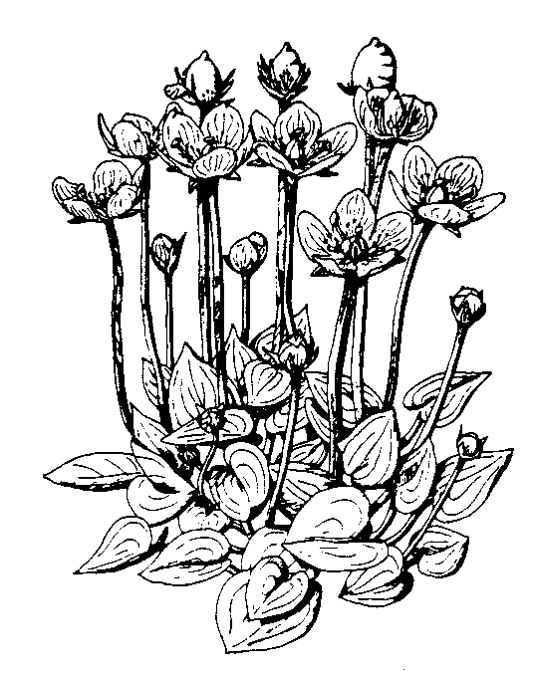2026 Field meetings

For information on the Society please
Contact Wendy Atkinson at World Museum, Liverpool
Tel: 0151 478 4216

wendy.atkinson@liverpoolmuseums.org.uk
www.livbotsoc.org

Officers 2026: -

President Steve Cross
Secretary Wendy Atkinson
Treasurer Robert Freeth
Editor Steve Cross
Librarian Wendy Atkinson

Attendance at field meetings is at members’ own risk. Please wear suitable footwear, waterproof clothing, and bring a packed lunch. For further information on membership application, safety in the field and the latest information, please see our website.

Members will need to pre-book with meeting leaders and give contact details (phone number), so we know who to expect and contact in the event of any last-minute changes.

Contact Wendy Atkinson or meeting leaders for further information.

Field Meetings 2026

** indicates joint field meetings with the Merseyside Naturalists’ Association, (MNA) Early booking is advised.

+ indicates a joint meeting with the Wildflower Society (WFS)

Meetings start at 10:30
Saturday April 18: Caergwrle
Leader - Steve Cross (07807 341220).
Meet at Caergwrle Station, Hawarden Road, LL12 9BL. (SJ3092157258). What 3 words: dairy.bookmark.preheated.
There is a car park in the village. Woodland and hedgerow plants.

Saturday April 25: City Nature Challenge. Rimrose Valley.
Leader - Steve Cross (07807 341220).
Meet at car park, Kirkstone Road West, Ford. L21 9LQ. Next to Our Lady Queen of Peace Roman Catholic Church, (SJ335987).
What3Words: crown.awards.rust..
All natural history.

+Saturday May 9: Croxteth Country Park, Liverpool
Leader - Steve Cross (07807 341220)
Meet at main car park off Muirhead Avenue East, L11 1EH. (SJ40483 94156).
What3Words: object.pass.flight.
Woodland plants. Limited places available.

Saturday May 30: Speke Hall
Leader - Steve Cross (07807 341220)
Meet at National Trust car park, The Walk, L24 1XD. (SJ422825). What3Words: monopoly.joys.family. Woodland plants.
Saturday June 6: Halewood Park Triangle
Leader - Steve Cross (07807 341220)
Meet at car park, Okell Drive, L26 7XB. (SJ4417985935). What3Words: weeps.workflow.fraction.
Woodland and ruderal plants.

**Saturday June 20: Haybridge
MNA coach trip, Cost £25.
Please book with MNA coach secretary Seema Aggarwal (07984 231059)
coachsecretary@mnapage.info

Sunday June 21: Pat Lockwood Memorial Walk. Green Beach, Ainsdale.
Leader - Steve Cross (07807 341220).
Meet at car park by Ainsdale Discovery Centre, PR8 2QB. (SD2978412694). What3Words: probably.professed.encloses.
Plants of saltmarsh, slacks and dunes.

+Saturday June 27: Liverpool City Centre & Everton
Leader - Steve Cross (07807 341220) Meet outside World Museum, William Brown Street, Liverpool, L3 8EN. (SJ34839075).
Urban Plants. Limited places available.

Saturday July 4: Crosby Beach
Leader – Steve Cross (07807 341220).
Meet at car park at Blucher Street, L22 8QA (SJ3131598202).
What3Words: forest.forced.shot.
Dune plants including Dune Wormwood and Isle of Man Cabbage.

Saturday July 11: Minera Quarry, near Wrexham, North Wales
Leader – Robert Freeth (07746 745774)
Meet in car park 800m down narrow lane off Maes-yffynnon Road, Minera (SJ258519)
Limestone plants of disused quarry & industrial site.

**Saturday July 18: Tegg’s Nose
MNA coach trip, Cost £25.
Please book with MNA coach secretary Seema Aggarwal (07984 231059)
coachsecretary@mnapage.info

Saturday July 25: Wirral Way
Leader - John Crowder (07977 736172)
Meet at pay & display car park at
CH61 0HN. (SJ2394783414)
Plants of meadows and hedgerows.

Saturday August 8: Leasowe, Wirral.
Leader – Steve Cross (07807 341220).
Meet at Leasowe Lighthouse Car Park, Lingham Lane, CH46 4TA. (SJ2518091340).
What3Words: bigger.calculating.cubes.
Dune and coastal plants.

Saturday August 22: Maghull & the Leeds-Liverpool canal.
Leader – Peter Gateley (07422 654161). Meet at Maghull Station, L31 3DE. (SD383015).
What3words: graced.saves.demotion.
Urban and aquatic plants including Duckweeds and Lesser reedmace.

Saturday September 26: Southport
Leader – Steve Cross (07807 341220)
Meet at The Lakeside Inn, Promenade, PR9 0EA. (SD3373817921). What3Words: asks.honey.lift.
Dune and Saltmarsh plants.

Saturday October 3: Rufford.
Leader – Peter Gateley (07422 654161)
Meet at Rufford station, L40 1TB (SD466156)
Plants of canal, riverbank and arable field edges.

Saturday October 24: Freshfield
Leader – Steve Cross (07807 341220). Meet at Freshfield station car park, L37 7DD. (SD2912408326).
What3Words: parent.cats.crass.
Fungi and any late flowering plants.

